Veterinary Appointment System

Course: Advance database system
Under the guidance of
prof. khomsun singhirunnusorn

Group-3:
ROHINI MUNIGANTI - 700762192
RISHIKA REDDY GANGAPURAM - 700765898
PADMINI BOLEM - 700763620
RAJA RAJESWARI - 700776644

PROJECT DISCRIPTION:
The Veterinary Appointment is a streamlined platform designed to improve the daily operations of veterinary clinics and enhance the experience for pet owners and staff. It offers a centralized system for managing appointments, health records, treatment details, and clinic oversight. By simplifying workflows, reducing paperwork, and maintaining consistent medical histories, the system helps improve animal care while supporting efficient clinic administration.
Pet owners can register accounts, manage multiple pet profiles, and schedule appointments based on veterinarian availability. Each profile contains species, breed, age, allergies, and treatment history. The system supports a wide range of pets—including dogs, cats, birds, rabbits, turtles, guinea pigs, reptiles, and other small domestic or exotic animals—making it adaptable to various veterinary practices. Owners can also upload documents such as vaccination records or insurance forms, receive appointment reminders, and track their payments and receipts for easy reference.
Veterinarians can access their schedules, review patient records before appointments, and log diagnoses, treatments, prescriptions, and care notes. After consultations, they can upload relevant medical files like lab results or scan images and schedule follow-up visits for chronic or ongoing conditions. This ensures continuity of care and helps veterinarians stay organized and informed when treating diverse animal cases.
Clinic administrators manage system users, medicines, pet categories, and clinic-wide data. They can create and assign user roles, define supported pet types, update the medicine inventory, monitor appointments, and oversee payment activity. Admins also have access to reports on treatment trends, common health issues, and clinic performance. This allows for data-driven planning, better resource use, and transparent operations.
Overall, the system fosters better coordination between pet owners and healthcare providers by making scheduling, communication, and recordkeeping seamless and secure. With every stakeholder equipped with the tools they need, the Veterinary Appointment System helps deliver organized, responsive, and high-quality veterinary care.

User Roles and Responsibilities
Pet Owner
- Register and log in
- Add and manage pet profiles
- Book and manage appointments
- Upload pet documents (e.g., vaccination, insurance)
- Receive reminders and view payment history
Veterinarian
- View appointment schedules
- Access pet medical records
- Record treatments, prescriptions, and notes
- Upload reports and schedule follow-ups
- Maintain continuity of care
Clinic Administrator
- Manage accounts and user roles
- Add and manage pet types and medicines
- Oversee appointments and payments
- Access reports on treatments and clinic trends
- Ensure smooth and transparent clinic operations

DATABASE DISCRIPTION:

The Veterinary Appointment System is a structured, role-based platform designed to streamline pet healthcare through efficient appointment scheduling, medical recordkeeping, and clinic administration. The system is built on interconnected collections, each storing essential data like pet information, user roles, clinical interactions, and financial transactions. Together, these collections form the backbone of the application’s functionality, enabling real-time access, historical tracking, and decision support for all users.

The customers collection stores data for all pet owners using the system. It includes fields like name, email, phone, and address to maintain contact and profile details. The password field secures login access, while status tracks whether the user is active or suspended. A created_at timestamp logs account creation. This collection serves as a parent for pets, appointments, and payments.

The vets collection contains information about veterinarians, including name, email, phone, and specialization to define their area of expertise. The password field handles authentication, and status (e.g., active, on leave) indicates availability. The created_at field is used to audit onboarding dates. This allows scheduling and recordkeeping to align with vet profiles.

The admins collection manages system-level users who control operations. Fields include name, email, phone, password, and role to distinguish access levels (e.g., admin or superadmin). The created_at timestamp provides traceability. Admins are responsible for managing pet types, user approvals, and overseeing clinic-wide data.

The pets collection holds individual pet profiles. Key fields include name, species, breed, gender, and age to describe the pet. The customer_id links the pet to its owner, and pet_type_id classifies it under predefined types. Allergies and notes store health observations or special care instructions. The created_at field captures when the pet was registered.

The pettypes collection defines the categories of pets treated by the clinic. Fields like name (e.g., Dog), category(Domestic, Exotic), and description provide clarity in classification. The created_by field records the admin who added the type, and created_at logs the timestamp. This collection supports accurate sorting and filtering of pets during treatment.

The appointments collection handles bookings between customers and vets. Each record includes customer_id, pet_id, and vet_id for relationship mapping. Appointment_date schedules the visit, while status tracks its progress (scheduled, completed, cancelled). Reason captures the visit's purpose, and notes can hold preliminary observations or follow-up instructions.

The treatments collection logs medical actions taken during appointments. It stores references like appointment_id, pet_id, and vet_id, along with clinical fields such as diagnosis, treatment_notes, and an array of prescriptions. A boolean follow_up_required field and optional follow_up_date support extended care. The created_at timestamp maintains chronological tracking.

The payments collection stores financial details tied to clinic services. It links to customer_id and appointment_id, and includes amount, payment_method (e.g., card, UPI, cash), and status (paid, pending, refunded). Receipt_url gives access to digital receipts, and paid_at and created_at track transaction history and timing.

Database Diagram:
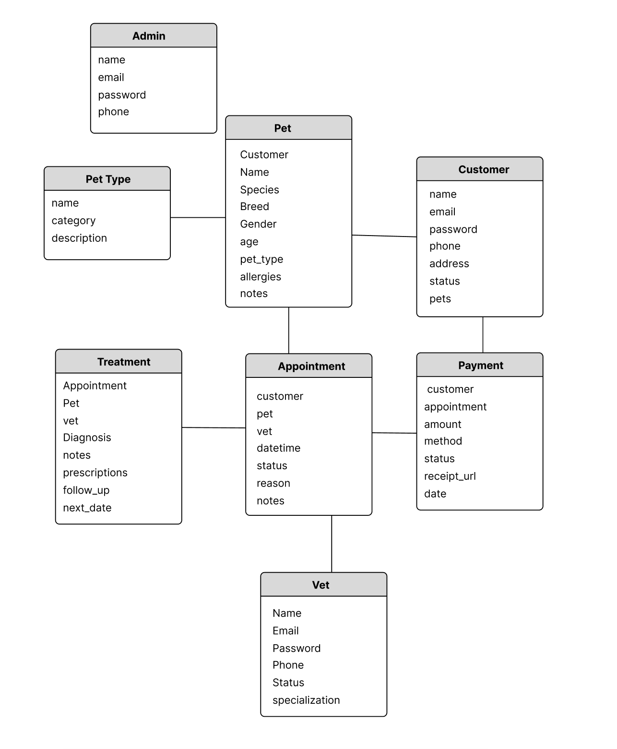

Mongo DB Collections:

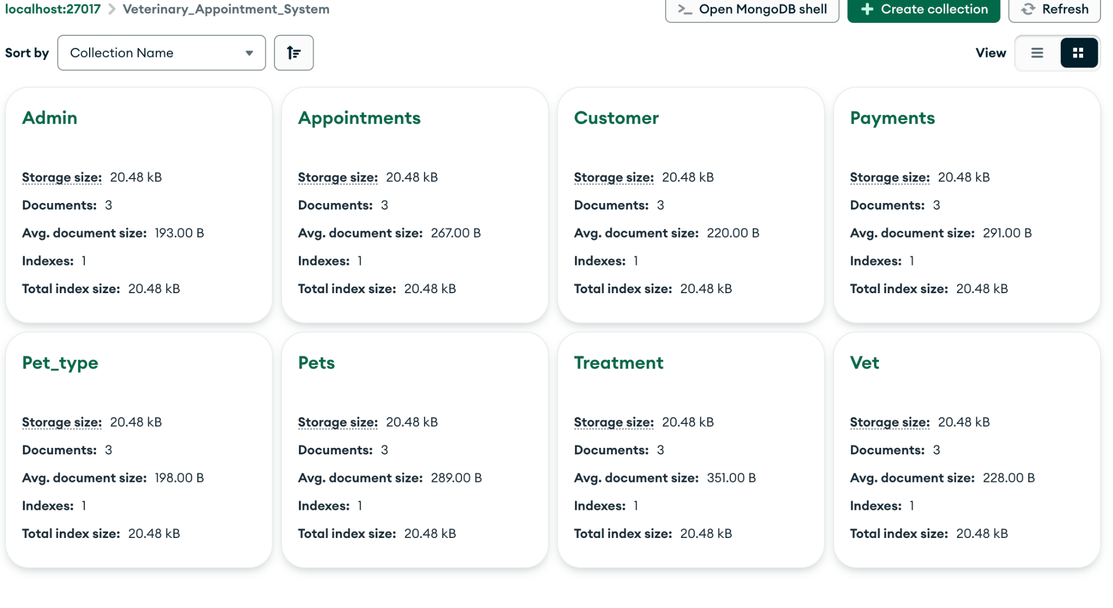Customer:
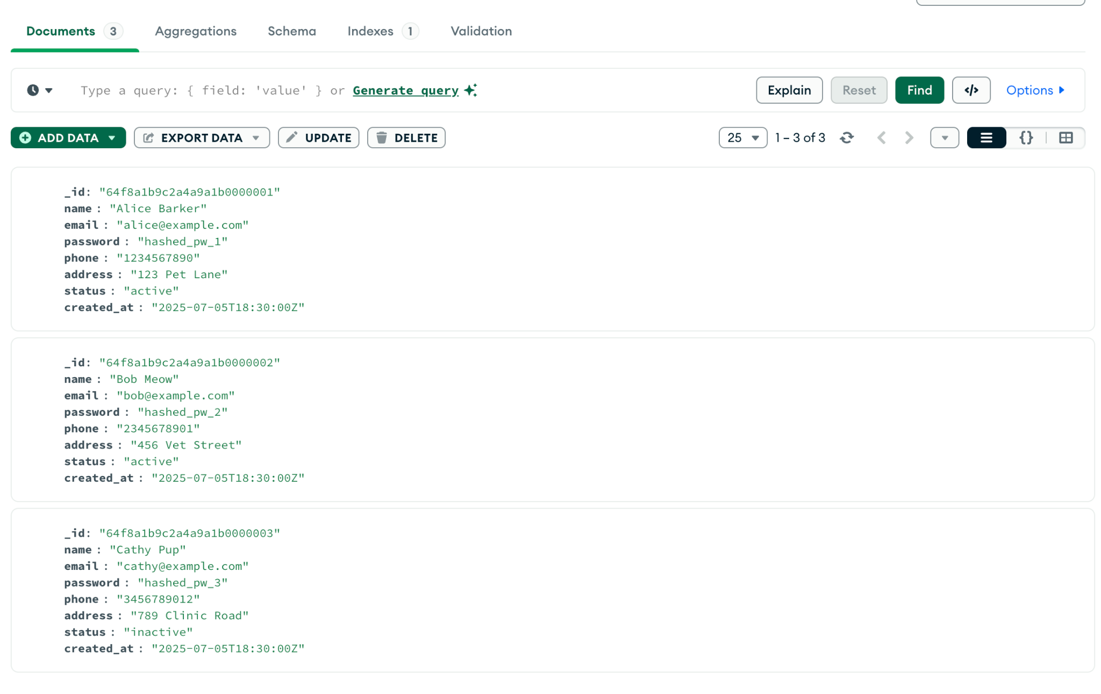

Vet:
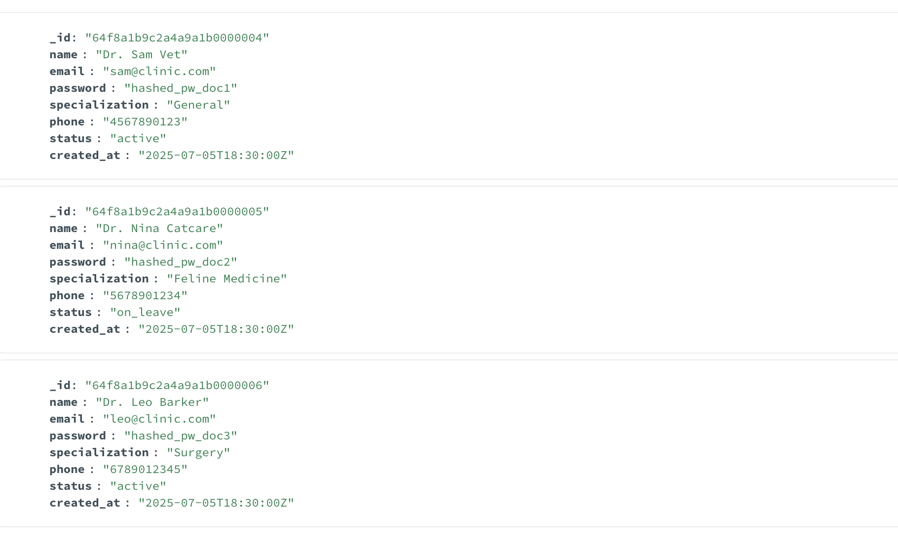
Admins:
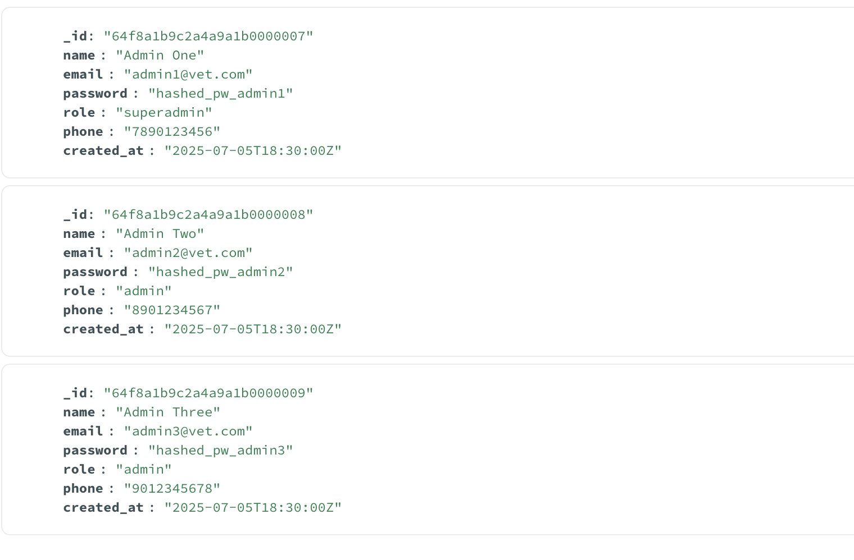

Pets:
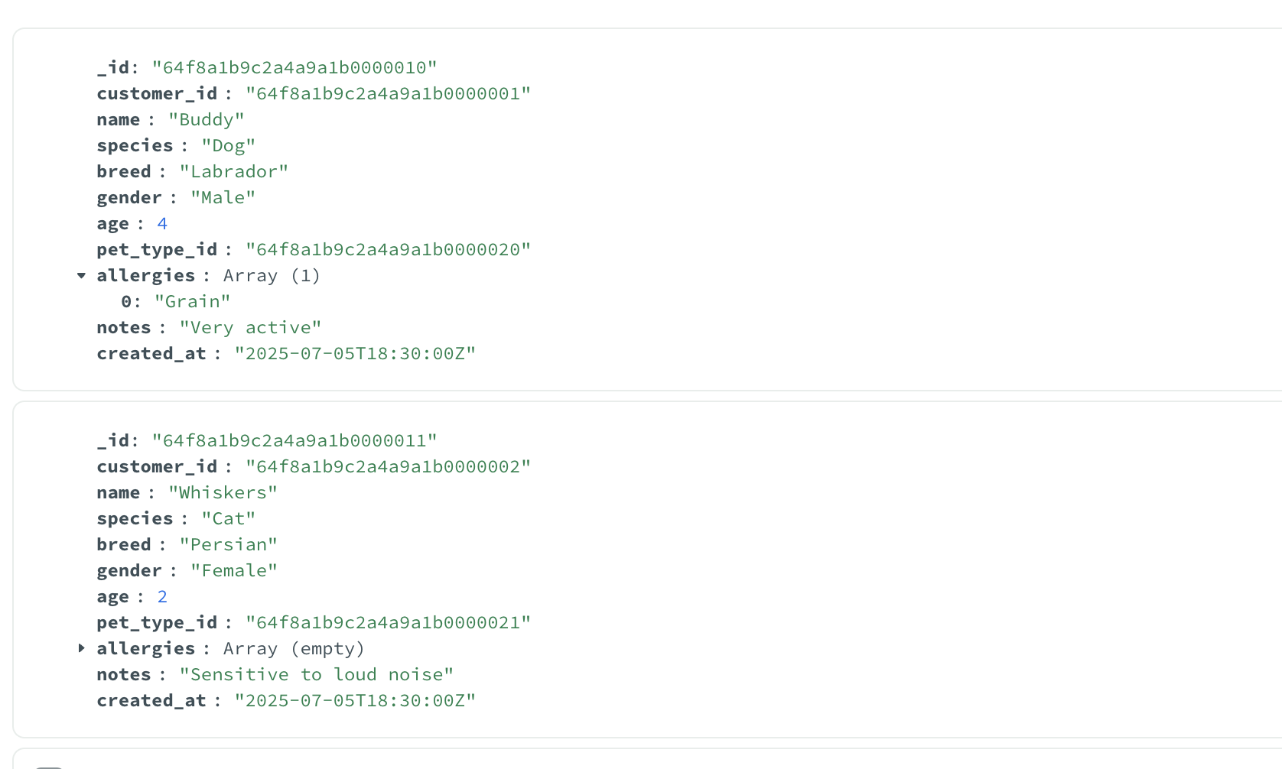

PetTypes:
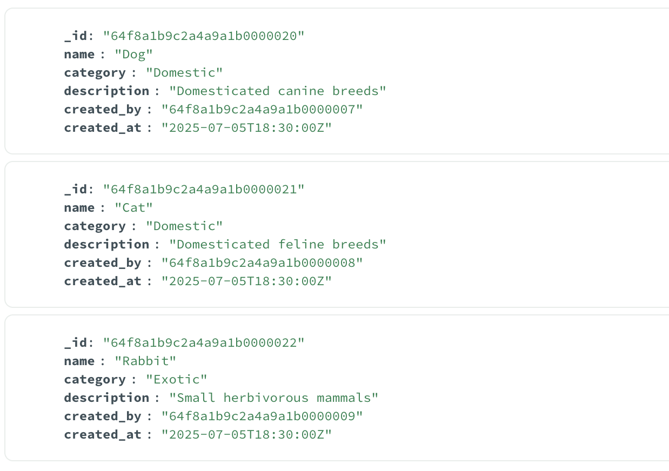

Appointments:

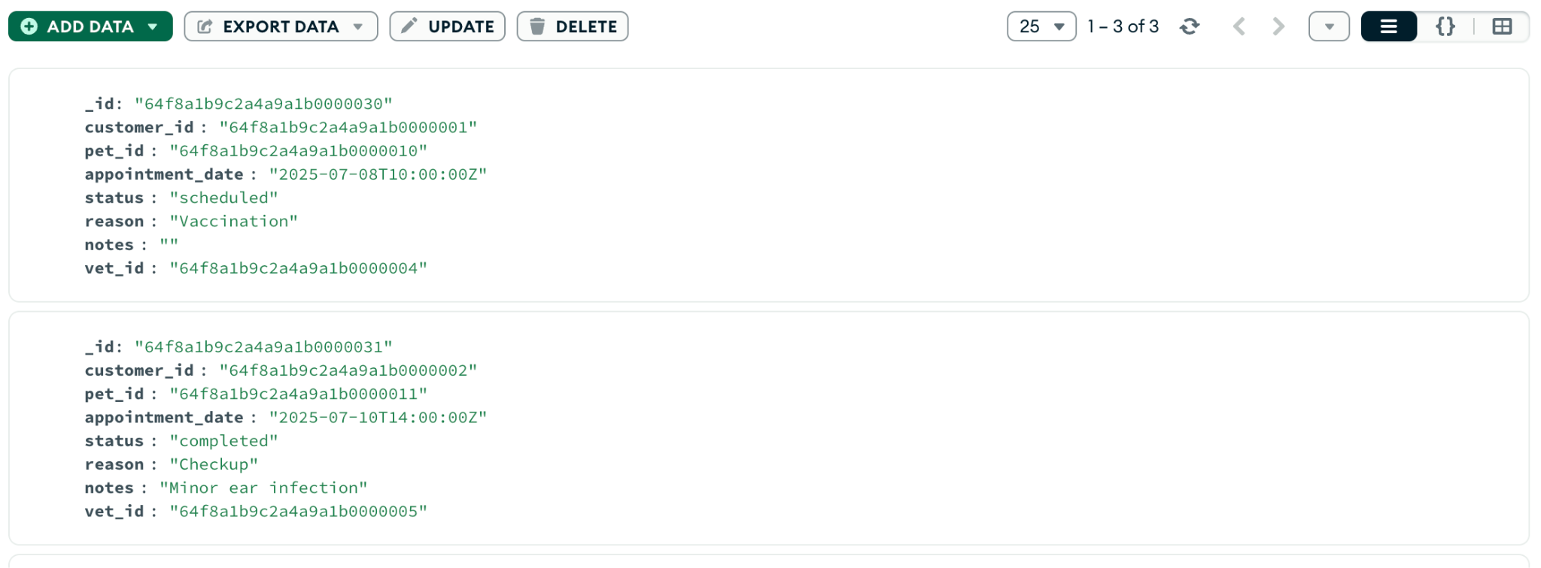
Treatments:

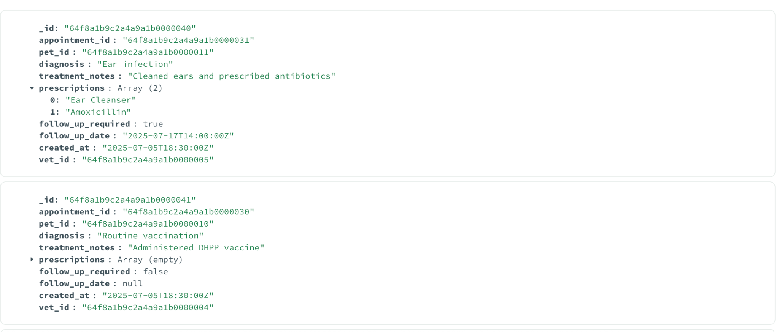

Payments:
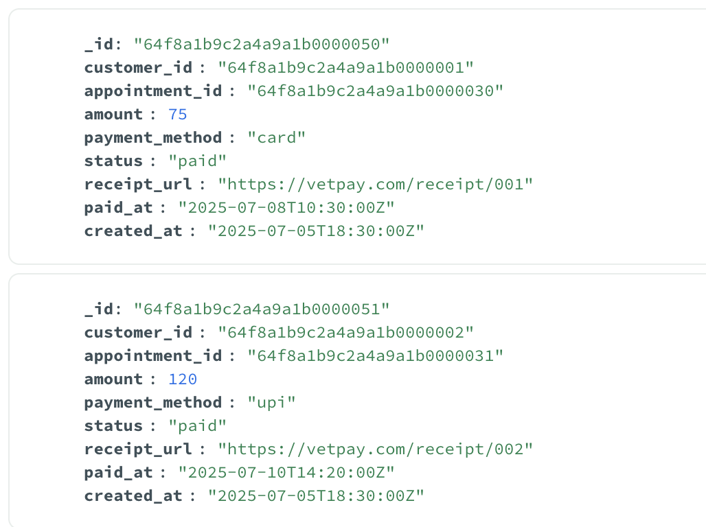

Sample Data:
Customers
{
"_id": "64f1c2a9e734f6f3a5b27e01",
"name": "Alice Thompson",
"email": "alice@example.com",
"password": "hashed_password_here",
"phone": "+1234567890",
"address": "123 Pet Lane, Springfield",
"status": "active",
"created_at": "2025-07-01T10:00:00Z"
}
Vet
{
"_id": "64f1c2d9e734f6f3a5b27e02",
"name": "Dr. Brian Lee",
"email": "dr.lee@vetclinic.com",
"password": "hashed_password_here",
"specialization": "Exotic Animals",
"phone": "+1987654321",
"status": "active",
"created_at": "2025-06-15T09:30:00Z"
}

Admins
{
"_id": "64f1c301e734f6f3a5b27e03",
"name": "Emma White",
"email": "admin@vetclinic.com",
"password": "hashed_admin_pass",
"role": "superadmin",
"phone": "+1122334455",
"created_at": "2025-06-01T08:00:00Z"
}
Pets
{
"_id": "64f1c329e734f6f3a5b27e04",
"customer_id": "64f1c2a9e734f6f3a5b27e01",
"name": "Max",
"species": "Dog",
"breed": "Labrador Retriever",
"gender": "Male",
"age": 4,
"pet_type_id": "64f1c3a9e734f6f3a5b27e08",
"allergies": ["Chicken", "Dust"],
"notes": "Very active, friendly temperament.",
"created_at": "2025-07-01T11:00:00Z"
}
Pettypes
{
"_id": "64f1c3a9e734f6f3a5b27e08",
"name": "Dog",
"category": "Domestic",
"description": "Domesticated canine companion.",
"created_by": "64f1c301e734f6f3a5b27e03",
"created_at": "2025-06-01T08:30:00Z"
}
Appointments
{
"_id": "64f1c3e9e734f6f3a5b27e05",
"customer_id": "64f1c2a9e734f6f3a5b27e01",
"pet_id": "64f1c329e734f6f3a5b27e04",
"vet_id": "64f1c2d9e734f6f3a5b27e02",
"appointment_date": "2025-07-10T14:30:00Z",
"status": "scheduled",
"reason": "Annual vaccination",
"notes": "Owner requested health checkup as well."
}

Treatments
{
"_id": "64f1c419e734f6f3a5b27e06",
"appointment_id": "64f1c3e9e734f6f3a5b27e05",
"pet_id": "64f1c329e734f6f3a5b27e04",
"vet_id": "64f1c2d9e734f6f3a5b27e02",
"diagnosis": "Healthy. No issues.",
"treatment_notes": "Administered annual rabies vaccine.",
"prescriptions": [],
"follow_up_required": false,
"follow_up_date": null,
"created_at": "2025-07-10T15:00:00Z"
}
Payments
{
"_id": "64f1c449e734f6f3a5b27e07",
"customer_id": "64f1c2a9e734f6f3a5b27e01",
"appointment_id": "64f1c3e9e734f6f3a5b27e05",
"amount": 50.0,
"payment_method": "Credit Card",
"status": "paid",
"receipt_url": "https://clinic.com/receipts/64f1c449e734f6f3a5b27e07",
"paid_at": "2025-07-10T15:05:00Z",
"created_at": "2025-07-10T15:05:00Z" }

Application Work Flow:
Registration page:
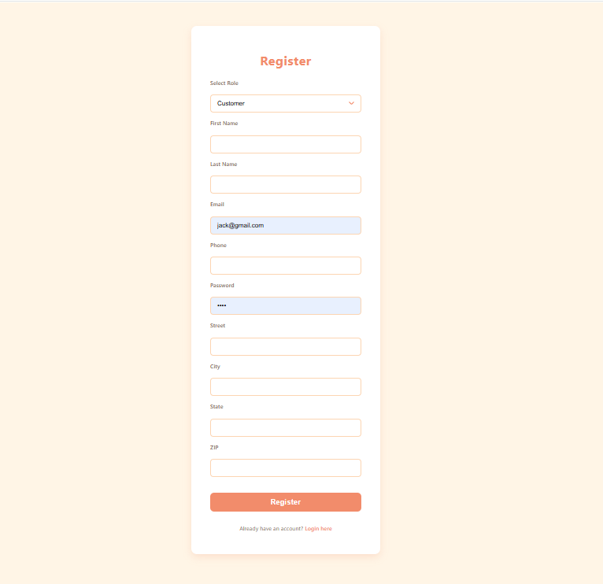

Login page:
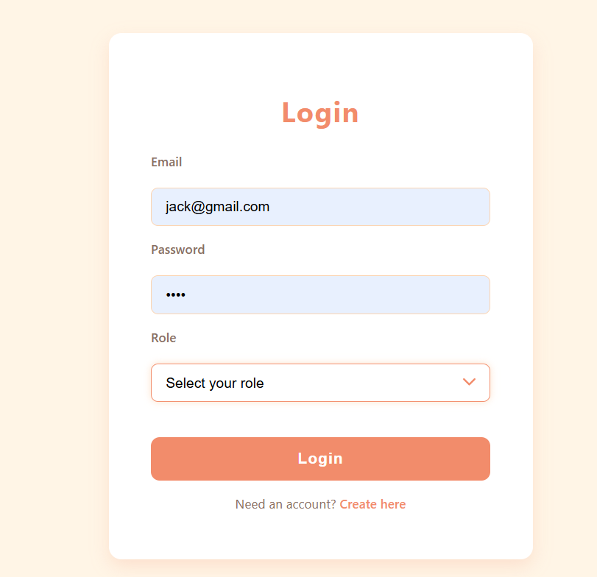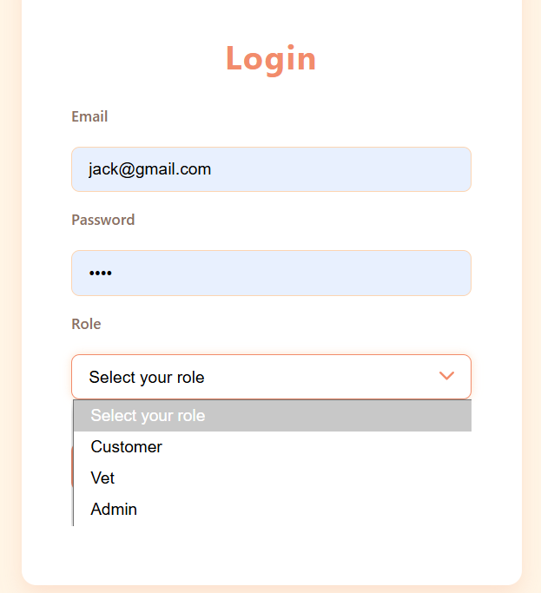

Application Roles
The application has three major roles:
1.Admin
2.Vet
3. Customer

Admin dash board:
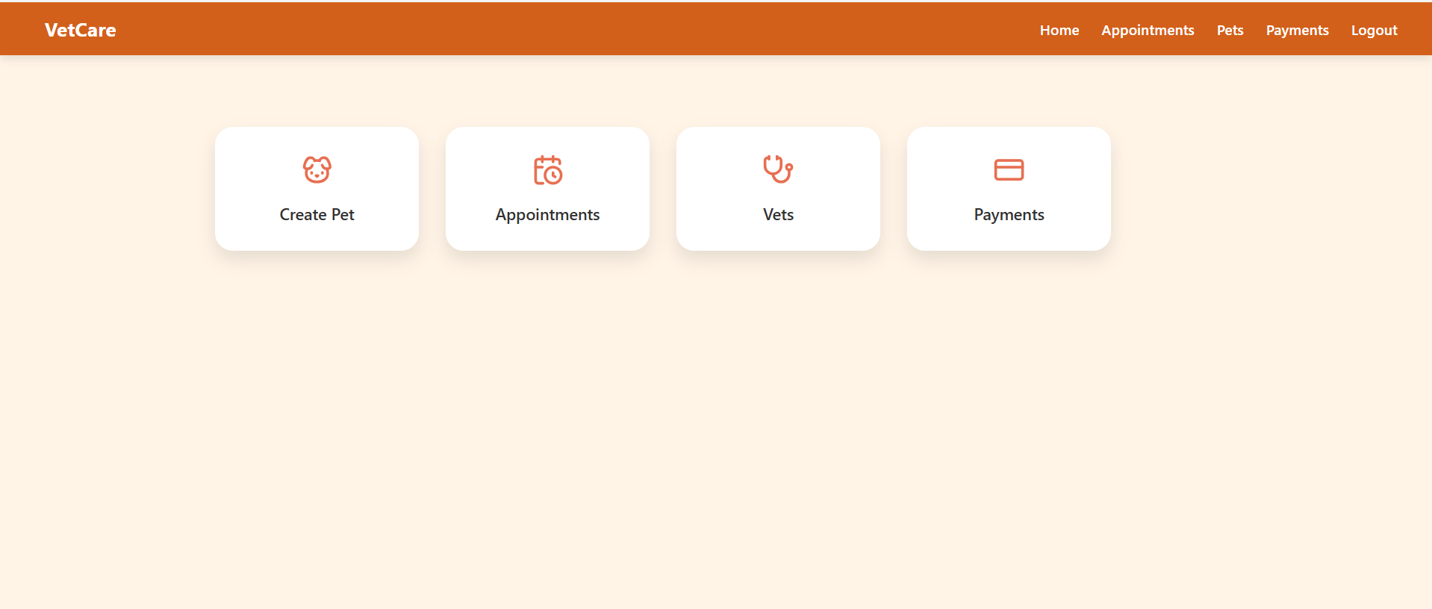

- Admin can create categories of pets and add breeds under each category.
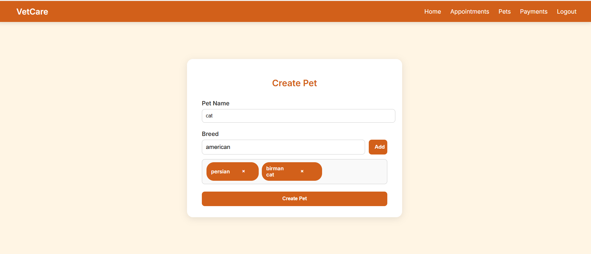

- Admin can approve vet registrations.
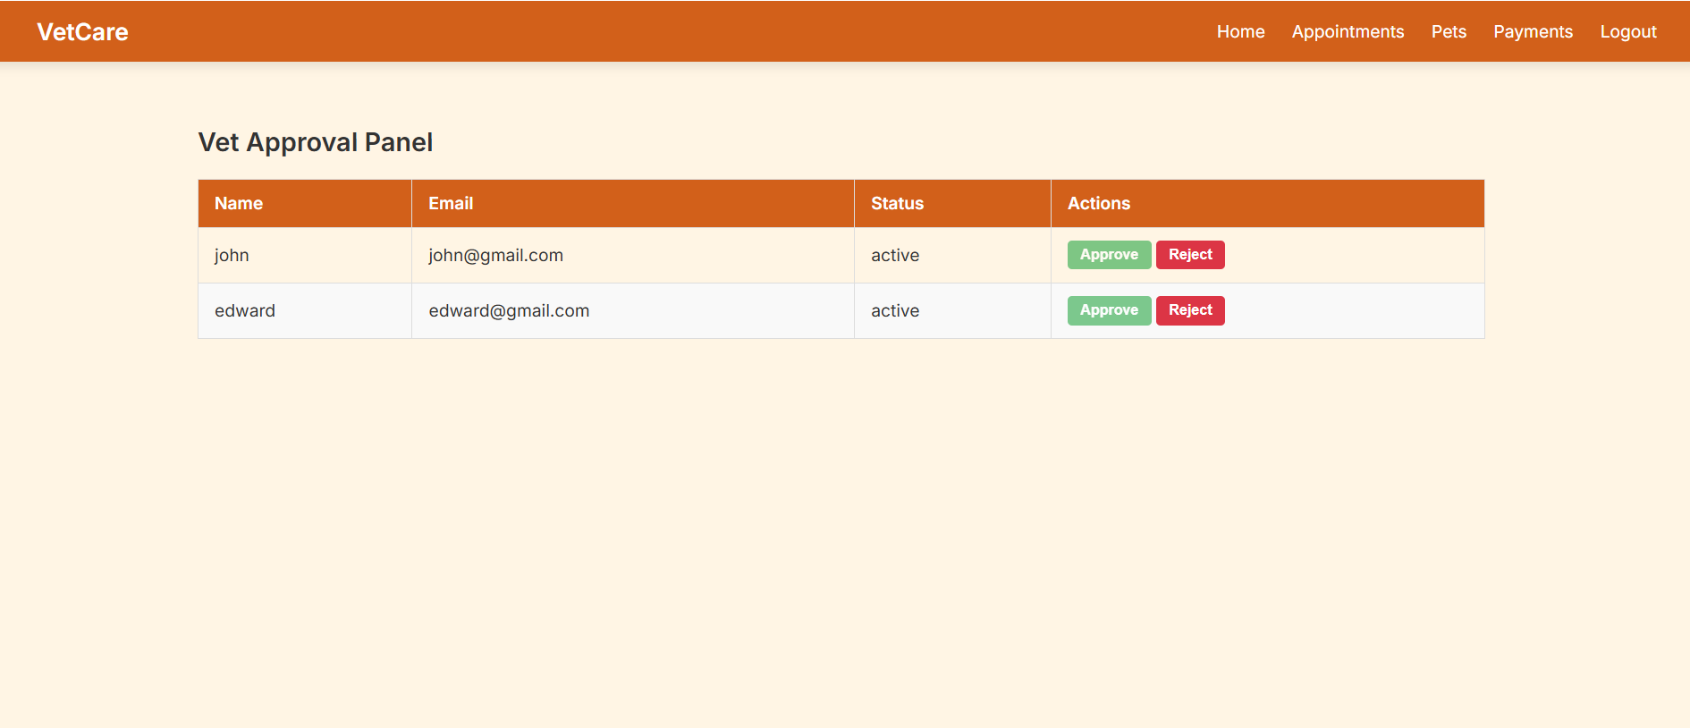

Customer dash board:
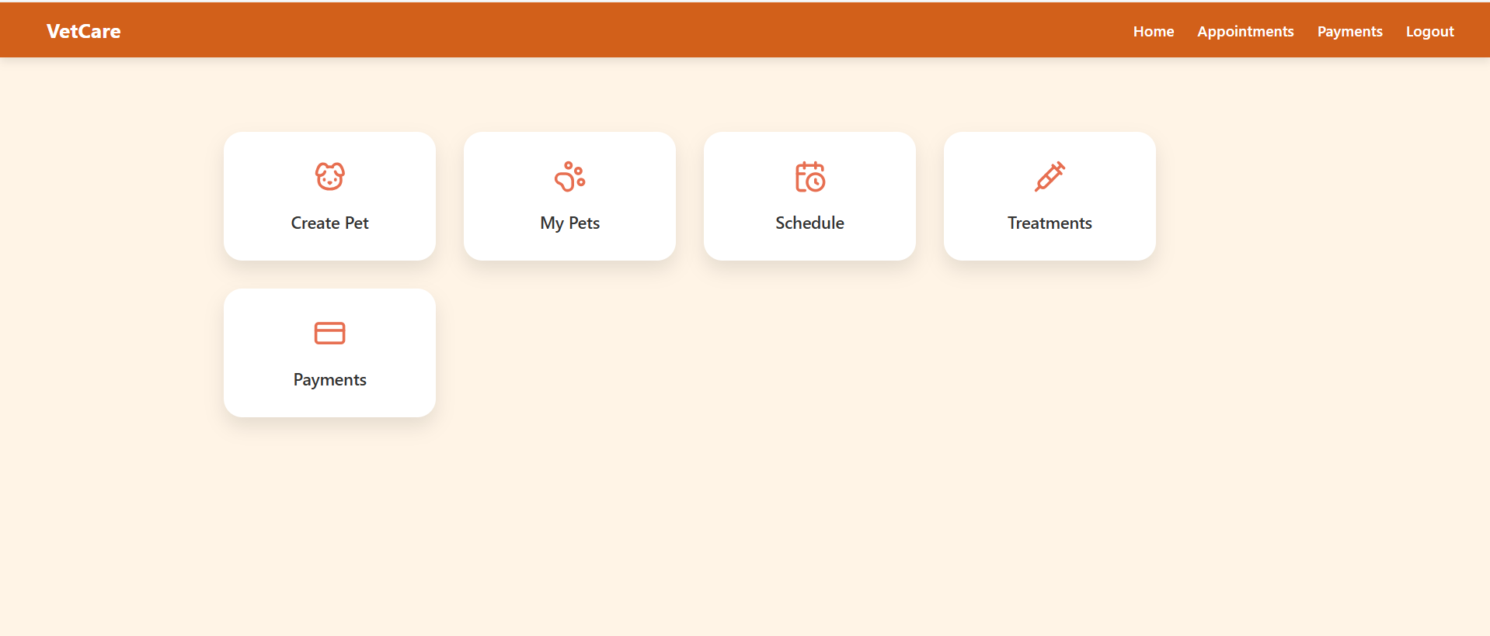

- Customers can add their pets to the system with relevant details.
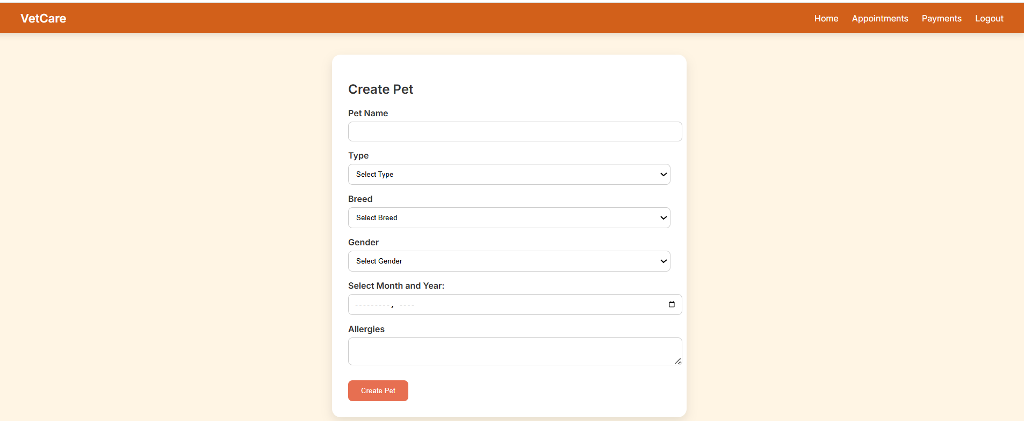

Pet details:
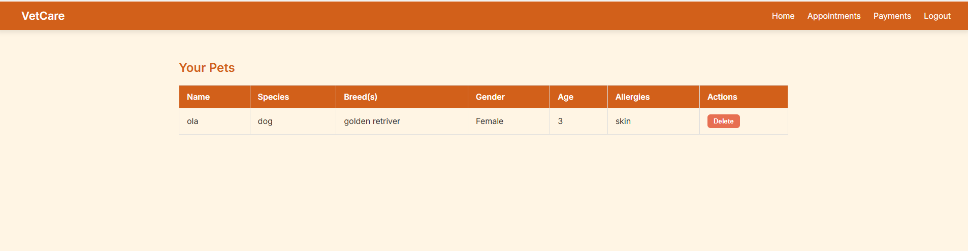

- Customers can schedule appointments for their pets.
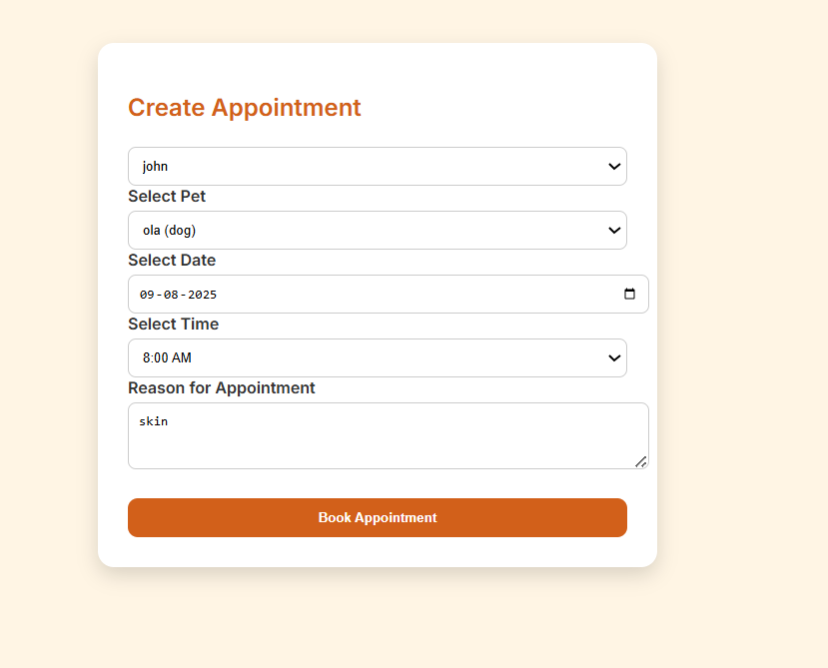
- Appointment status initially appears as "Requested" in the Treatments section.
- Once a vet is assigned by the admin, the status updates to "Assigned".
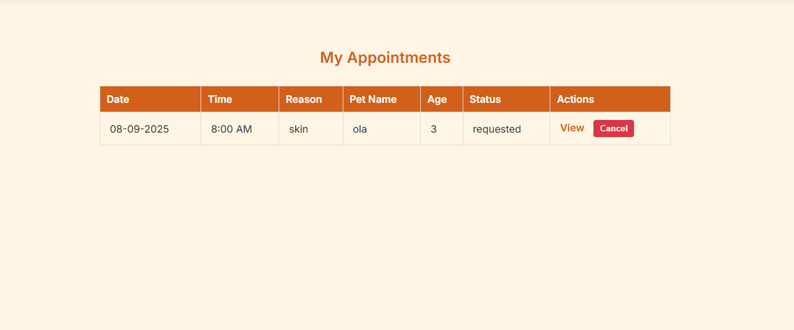

Vet dashboard
- Vets can view their appointments.
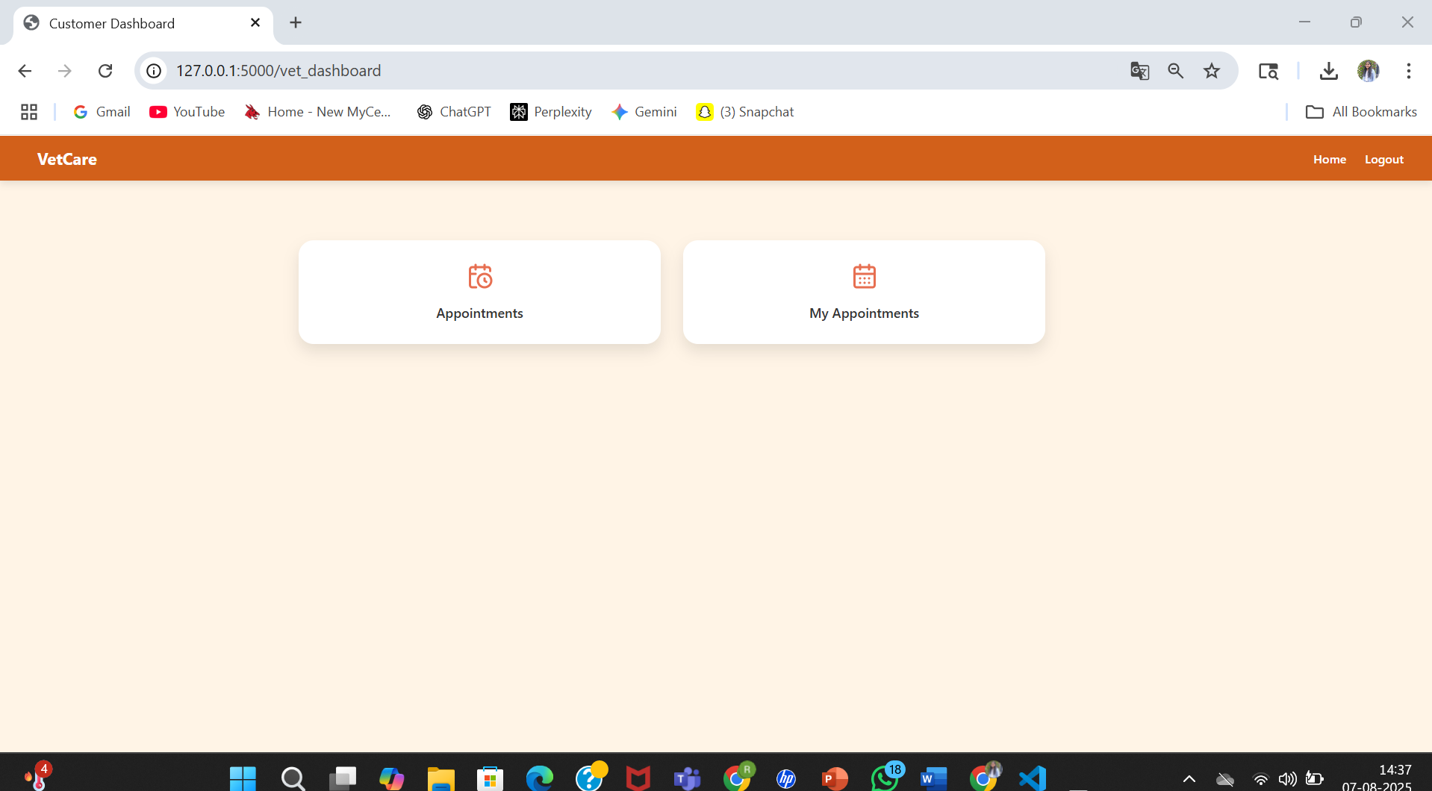

- Vets can set and update their availability.
- Use "Create Appointment" to set availability.
- Use "Edit Appointment" to modify availability.

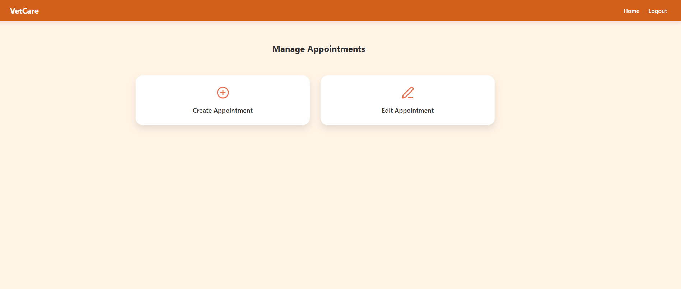
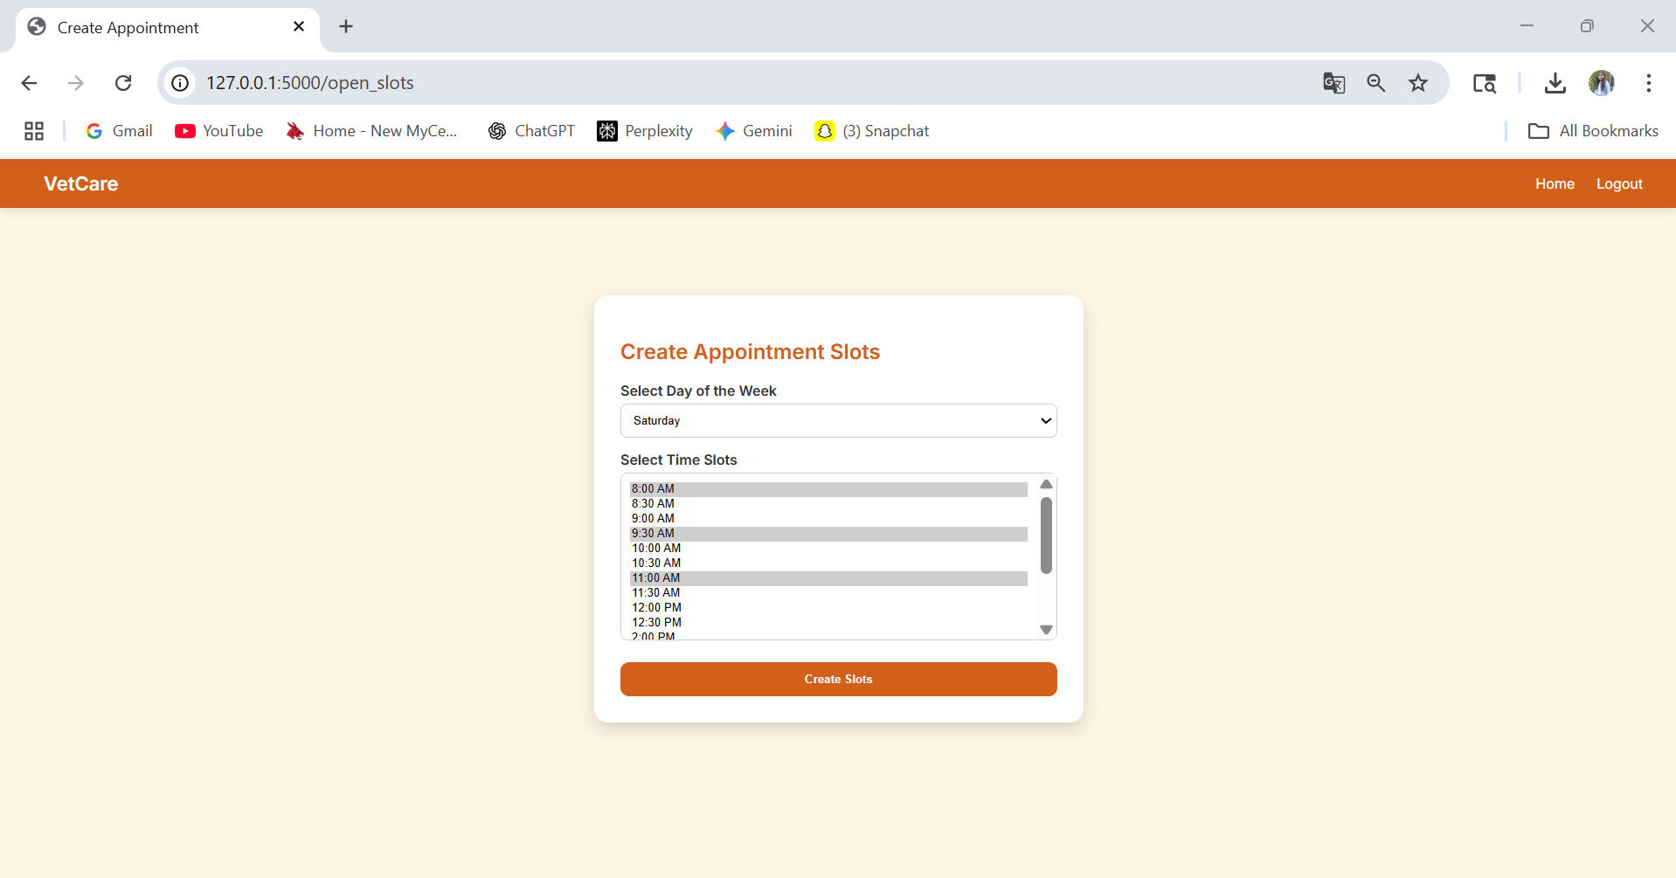

- Admin can view all customer appointments.
- Admin can assign vets to customer appointments.
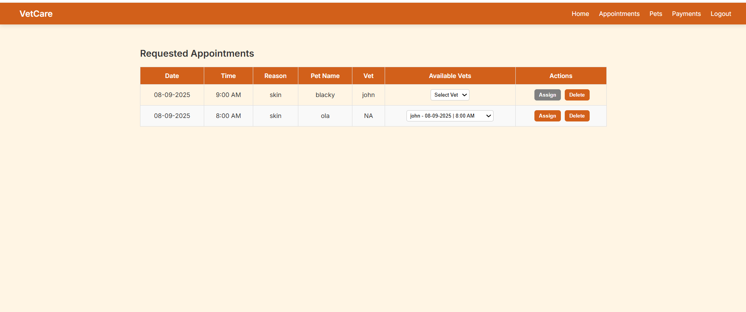

- Once a vet is assigned by the admin, the status updates to "Assigned" in the customer dashboard under treatments.
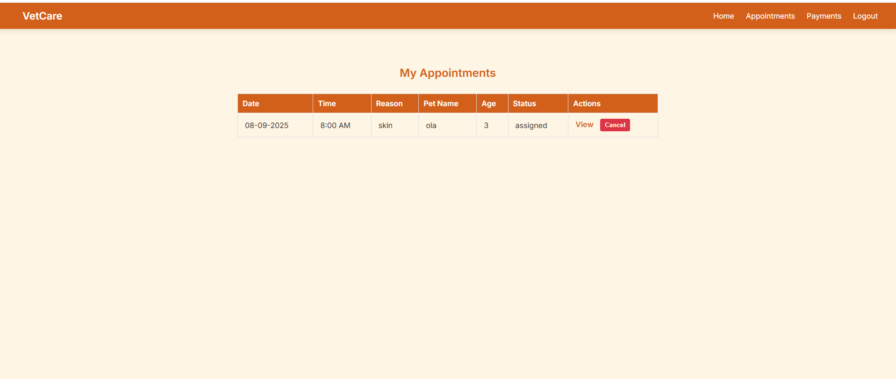
-Now after assignment vet can login in to his dashboard and check under my assigned appointments.
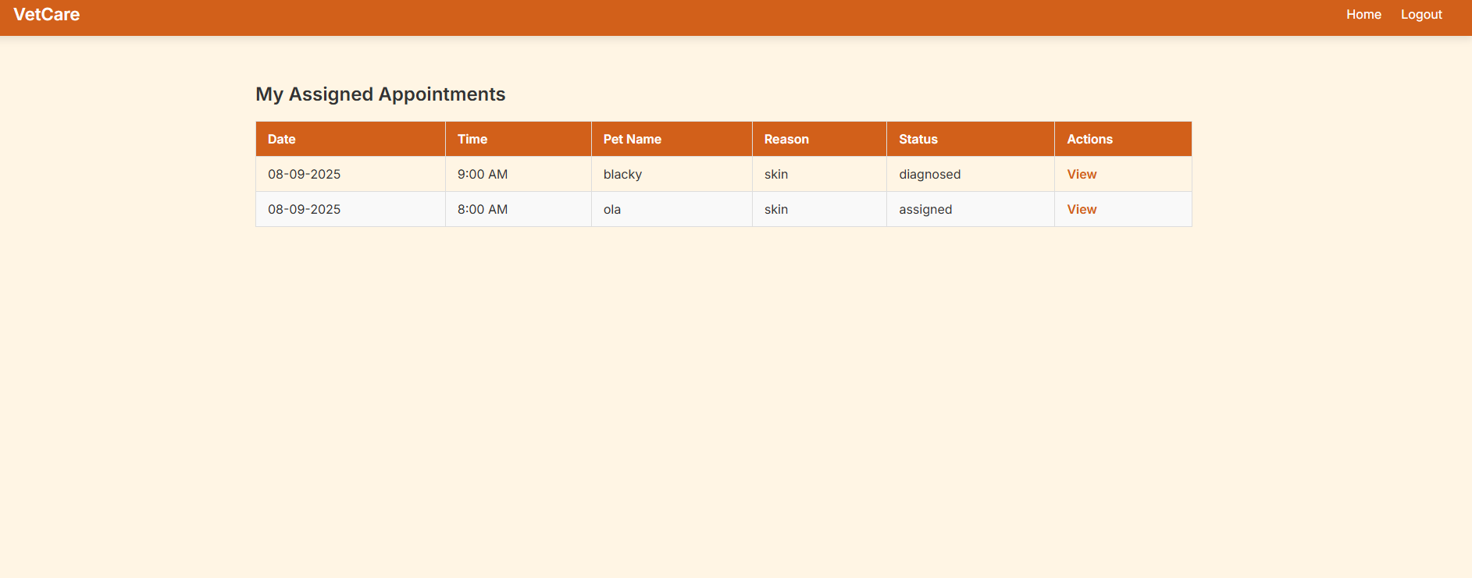

- Vets can view appointment, customer, and pet details.
- Vets can add prescriptions, set follow-up dates, and add diagnosis fees.
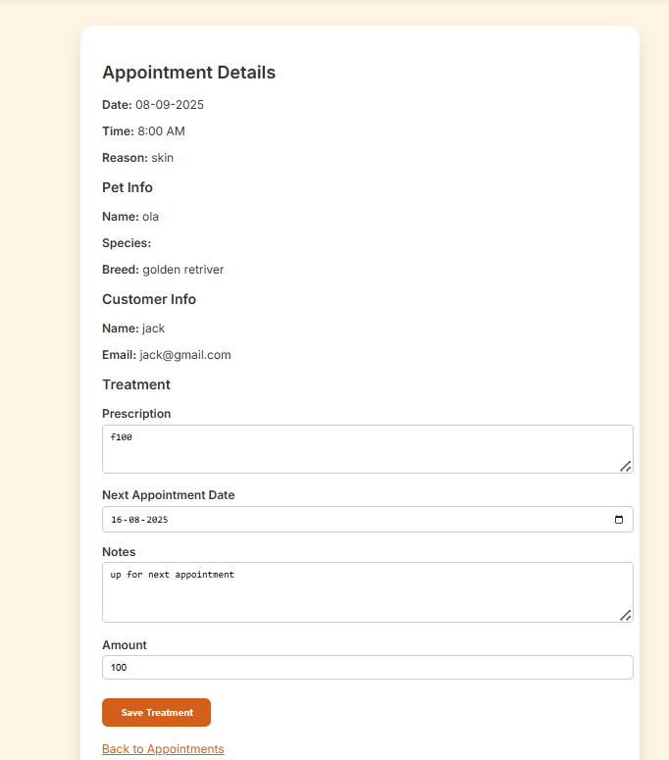

Post-Treatment (Customer)
- Customers can log in after treatment to review the diagnosis and make payments.
- Completed payments are reflected under the Payments section.

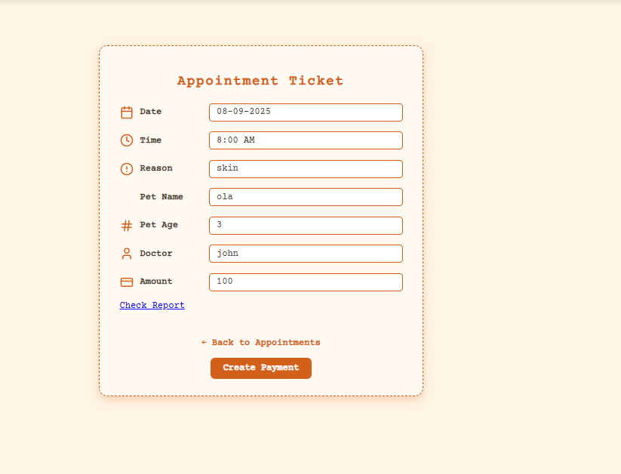

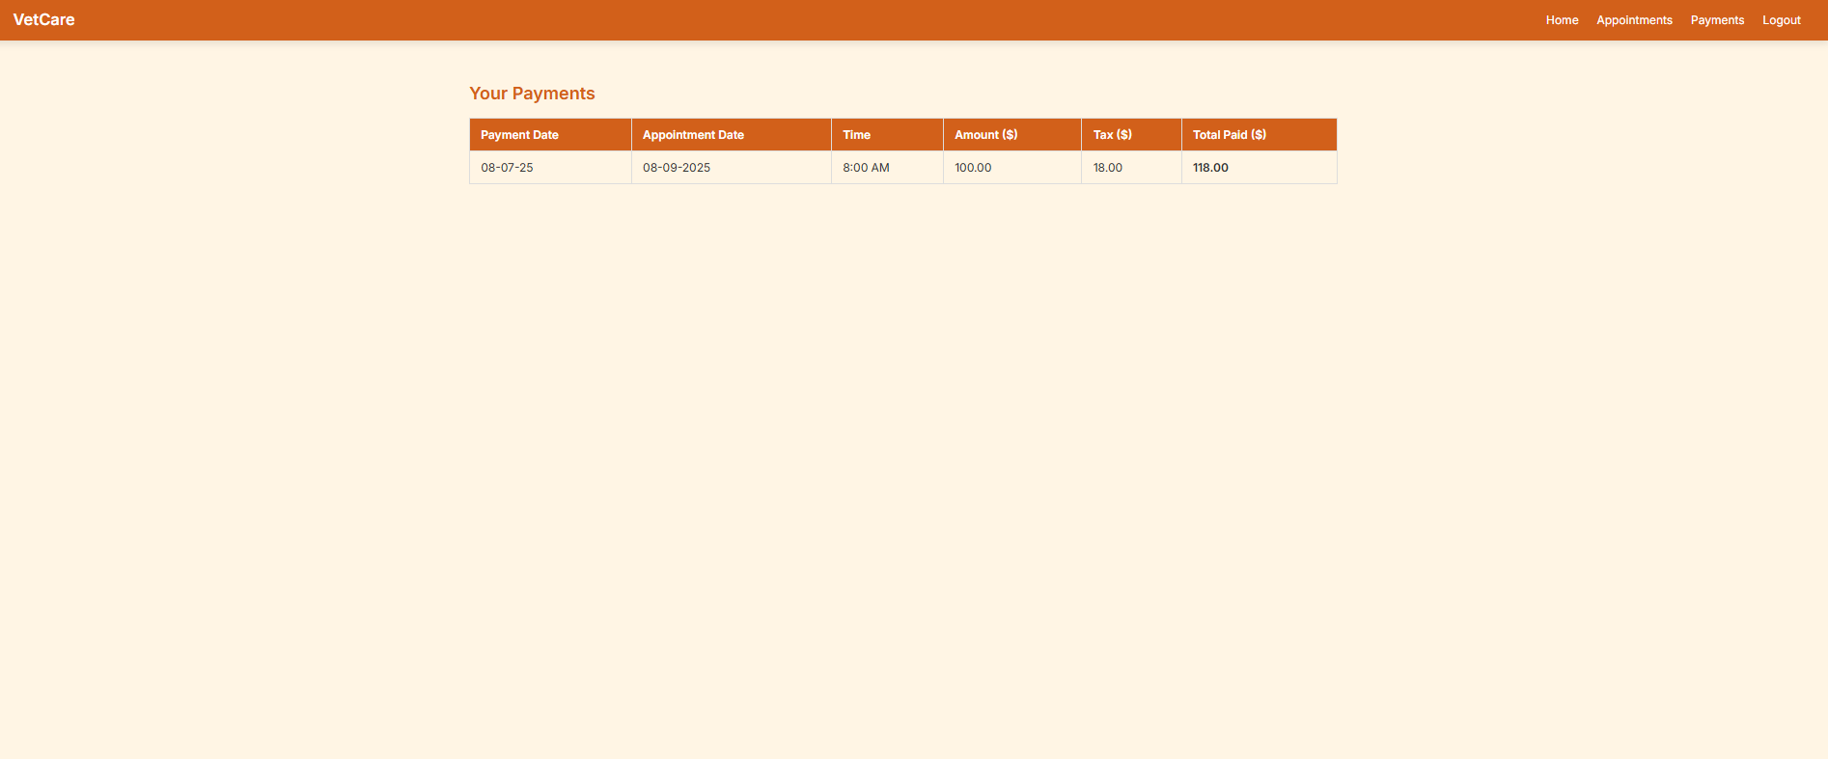
CONCLUSION:
The Veterinary Appointment System is a comprehensive and thoughtfully designed solution aimed at transforming the way veterinary clinics operate. It streamlines the end-to-end workflow of animal care—from scheduling appointments to maintaining treatment records—making it easier for pet owners, veterinarians, and clinic administrators to stay connected and organized.
At the heart of the system lies a role-based structure that ensures personalized experiences for each user type:
- Admins have full oversight and control. They can create pet categories and breeds, approve veterinarians, assign vets to appointments, manage users, and monitor the overall functioning of the clinic. This ensures centralized coordination and efficient clinic management.
- Veterinarians can manage their availability, view and respond to appointments, diagnose pet conditions, prescribe treatments, and schedule follow-up visits. This ensures that each vet can maintain detailed and up-to-date medical records, fostering continuity in care.
- Customers (Pet Owners) have the ability to register themselves, add pet profiles with detailed information, schedule appointments based on vet availability, and track their appointment status in real time. After treatment, they can proceed with payments and access treatment and payment history, making their journey seamless and transparent.
The workflow is simple yet powerful: customers request appointments → admins assign a vet → vets diagnose and record treatment → customers make payment after treatment. At every stage, the platform ensures data integrity, accountability, and ease of use.
The inclusion of document uploads, appointment reminders, payment tracking, and role-based dashboards provides a modern digital experience tailored to real veterinary practices. By reducing paperwork, centralizing information, and automating key processes, the system minimizes manual effort while maximizing care quality and operational efficiency.
In conclusion, this project not only showcases strong technical implementation but also solves real-world problems in the veterinary field. It demonstrates how thoughtful software development can improve healthcare workflows, enhance communication, and ultimately contribute to better animal care and clinic management. The Veterinary Appointment System stands as a scalable, secure, and user-centric solution that brings value to all stakeholders involved.

